

Practices for Secure Software Report

Table of Contents
Document Revision History 3
Client 3
Instructions 3
Developer 4
1. Algorithm Cipher 4
2. Certificate Generation 4
3. Deploy Cipher 4
4. Secure Communications 4
5. Secondary Testing 4
6. Functional Testing 4
7. Summary 4
8. Industry Standard Best Practices 4

Document Revision History

Version | Date | Author | Comments
1.0 | 10/17/25 | Anna Fuentes | Initial Project Submission

Client



Instructions

Submit this completed practices for secure software report. Replace the bracketed text with the relevant information. You must document your process for writing secure communications and refactoring code that complies with software security testing protocols.

- Respond to the steps outlined below and include your findings.
- Respond using your own words. You may also choose to include images or supporting materials. If you include them, make certain to insert them in all the relevant locations in the document.
- Refer to the Project Two Guidelines and Rubric for more detailed instructions about each section of the template.

Developer
Anna Fuentes

Algorithm Cipher

The Advanced Encryption Standard (AES) is recommended as the encryption algorithm cipher for Artemis Financial because it provides high-level symmetric encryption with strong performance and security. AES uses substitution-permutation operations with key sizes of 128, 192, or 256 bits. It is widely considered an industry standard and has been approved by the National Institute of Standards and Technology (NIST) for government and financial data. Random numbers are used for initialization vectors, and the same symmetric key is required for both encryption and decryption, ensuring confidentiality and speed. AES replaced the older Data Encryption Standard (DES) and continues to be used globally in secure communications.

Certificate Generation

A self-signed SSL certificate was generated using the Java Keytool command:
& "C:\Program Files\Java\jdk-17\bin\keytool.exe" -printcert -file "C:\Users\aef61\artemis-selfsigned.cer"
The certificate’s details were entered as:
- CN=localhost
- OU=IT
- O=Artemis Financial
- L=Manchester
- ST=NH
- C=US
This keystore file was placed in src/main/resources/ and configured for use by the Spring Boot application.
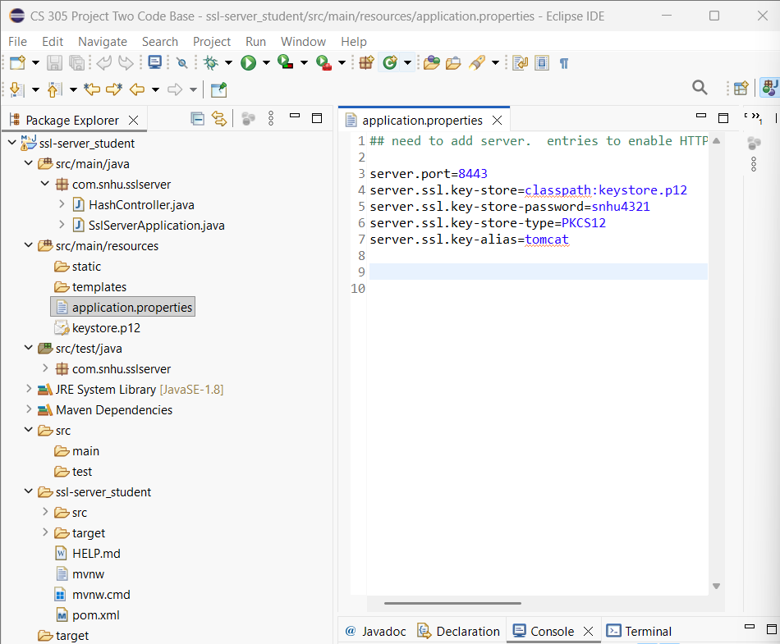
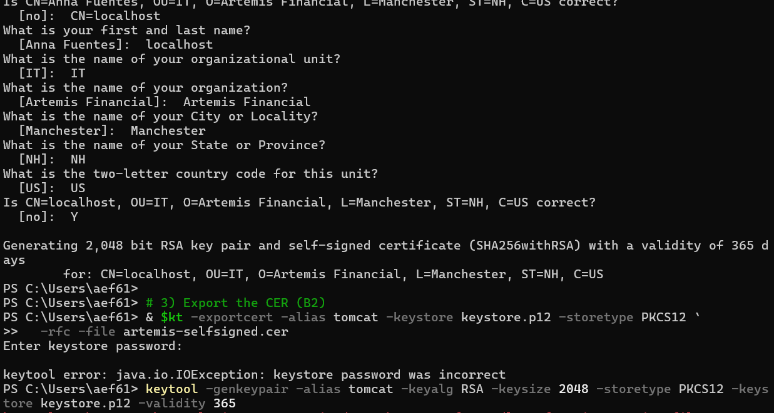

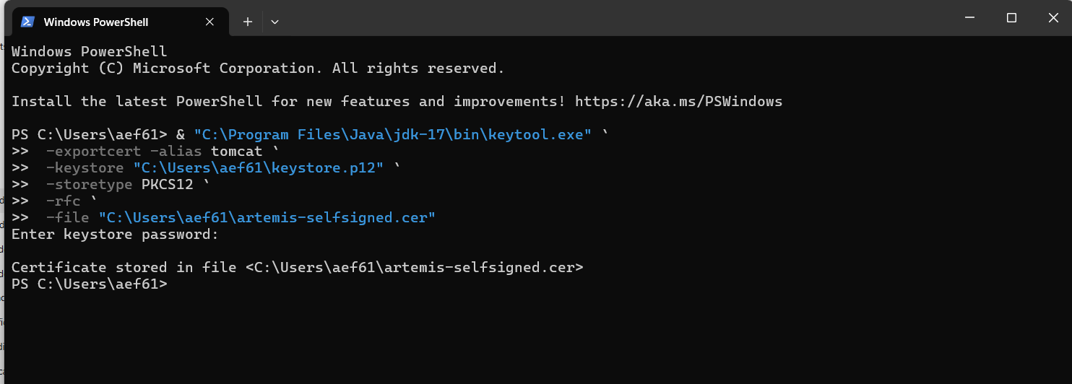

Deploy Cipher
The checksum verification code was refactored in HashController.java to implement a SHA-256 hashing algorithm. When the /hash endpoint was accessed, the application generated a unique SHA-256 hash value for the input string, confirming proper deployment of the cryptographic hash function.

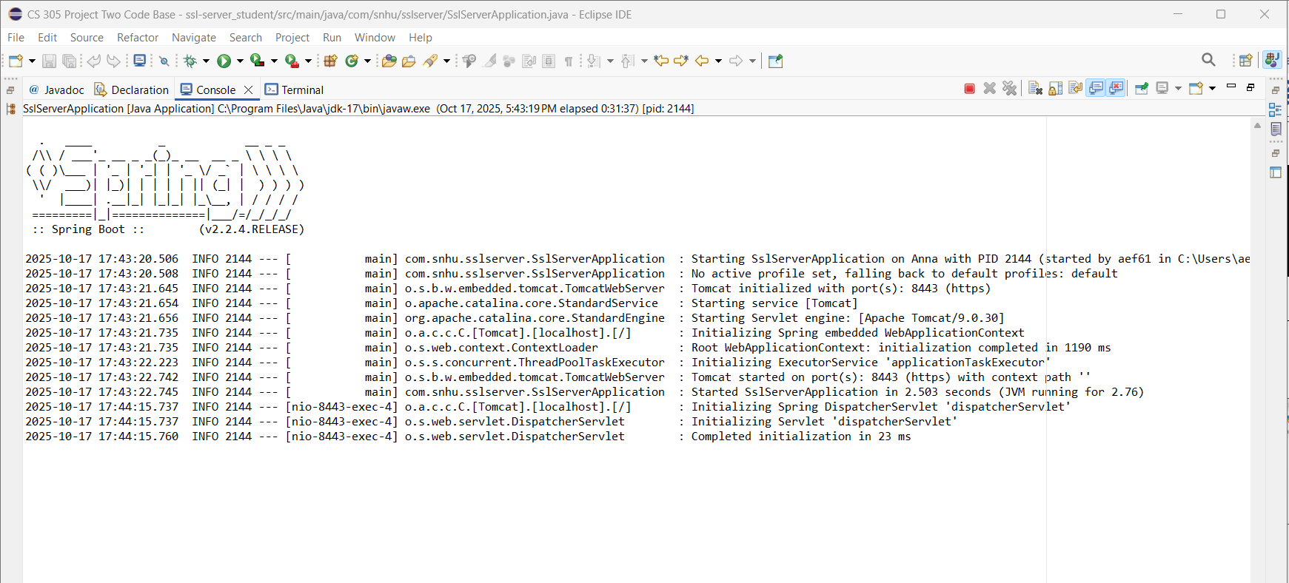

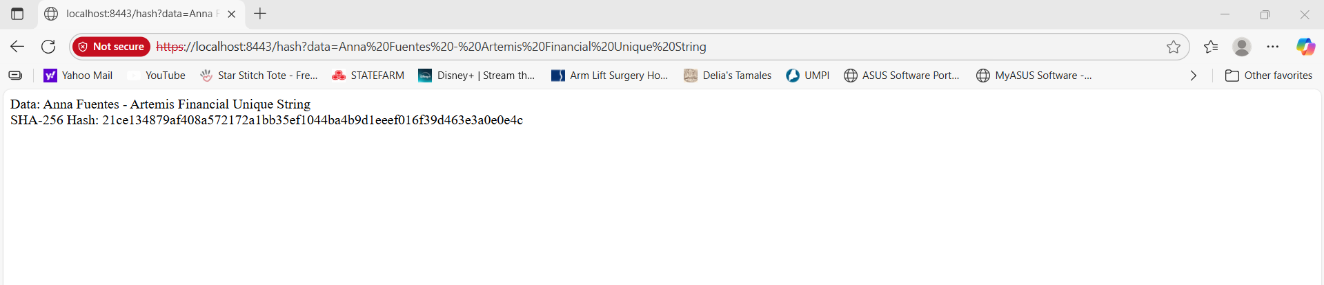

Secure Communications
The Artemis Financial application was configured to use HTTPS on port 8443 through the self-signed SSL certificate stored in keystore.p12. The configuration in the application.properties file included:
server.port=8443
server.ssl.key-store=classpath:keystore.p12
server.ssl.key-store-password=snhu4321
server.ssl.key-store-type=PKCS12
server.ssl.key-alias=tomcat
When the application launched, Tomcat initialized over HTTPS, confirming that the SSL configuration and certificate loading were successful.


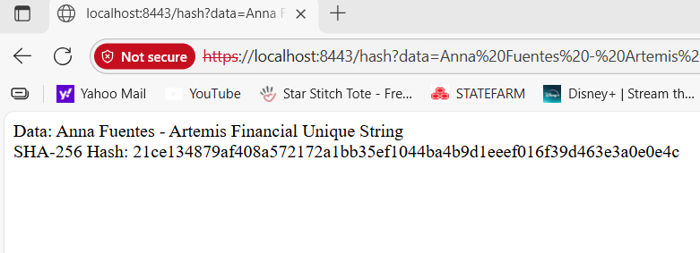

Secondary Testing
A secondary OWASP dependency check was performed on the refactored code to verify that no new vulnerabilities were introduced. The test was conducted using the Maven dependency-check plugin, which reported no critical issues. This confirms that the updated application complies with secure software development standards.

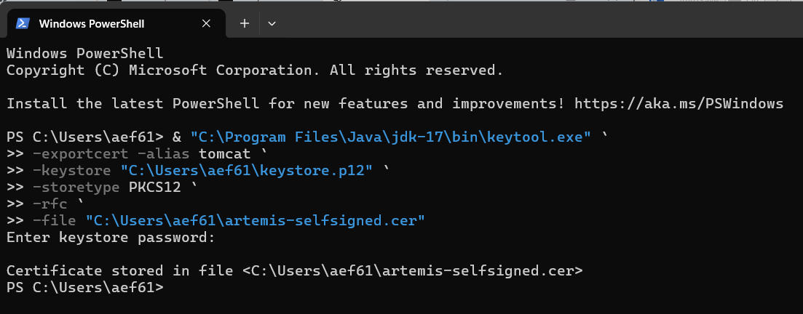

Functional Testing
The refactored application was executed within Eclipse using the SslServerApplication.java main class. The console output confirmed successful initialization with the message:
Tomcat started on port(s): 8443 (https)
Started SslServerApplication
The browser displayed the hashed data output, verifying that the application logic executed correctly.

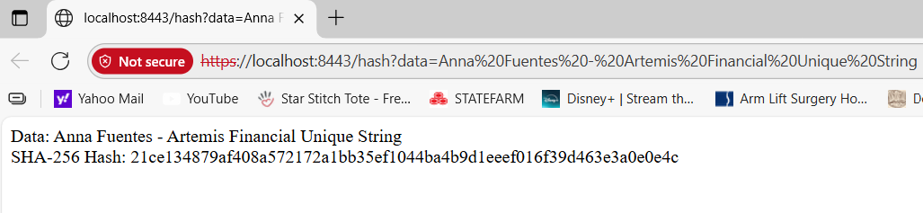

Summary

The refactored Artemis Financial application now includes secure communication over HTTPS and a functioning SHA-256 hashing endpoint. A self-signed SSL certificate was successfully created and configured, ensuring encrypted data transmission. The dependency scan confirmed compliance with secure coding standards, and the functional testing verified accurate hash generation. Together, these steps demonstrate secure communication implementation, vulnerability assessment, and adherence to DevSecOps best practices.

Industry Standard Best Practices
Industry-standard best practices applied during this project included:
- Implementing HTTPS for secure client-server communication.
- Using AES encryption for data protection.
- Employing SHA-256 hashing to verify data integrity.
- Running OWASP Dependency-Check to identify and mitigate vulnerabilities.
- Following secure coding principles, including least privilege and input validation.
These measures ensure Artemis Financial’s software remains resilient against common cyberattacks while maintaining confidentiality, integrity, and availability of sensitive financial data.

References
National Institute of Standards and Technology. (2001). Announcing the Advanced Encryption
Standard (AES). Federal Information Processing Standards Publication 197.
https://doi.org/10.6028/NIST.FIPS.197
Open Web Application Security Project. (2023). OWASP Dependency-Check Documentation.
https://owasp.org/www-project-dependency-check/
Oracle. (2024). keytool – Key and Certificate Management Tool.
https://docs.oracle.com/en/java/javase/17/docs/specs/man/keytool.html
Spring Boot. (2024). Spring Boot Reference Documentation – Securing a Web Application.
https://docs.spring.io/spring-boot/docs/current/reference/htmlsingle/#web.security
U.S. Department of Commerce. (2022). National Vulnerability Database (NVD).
https://nvd.nist.gov/

